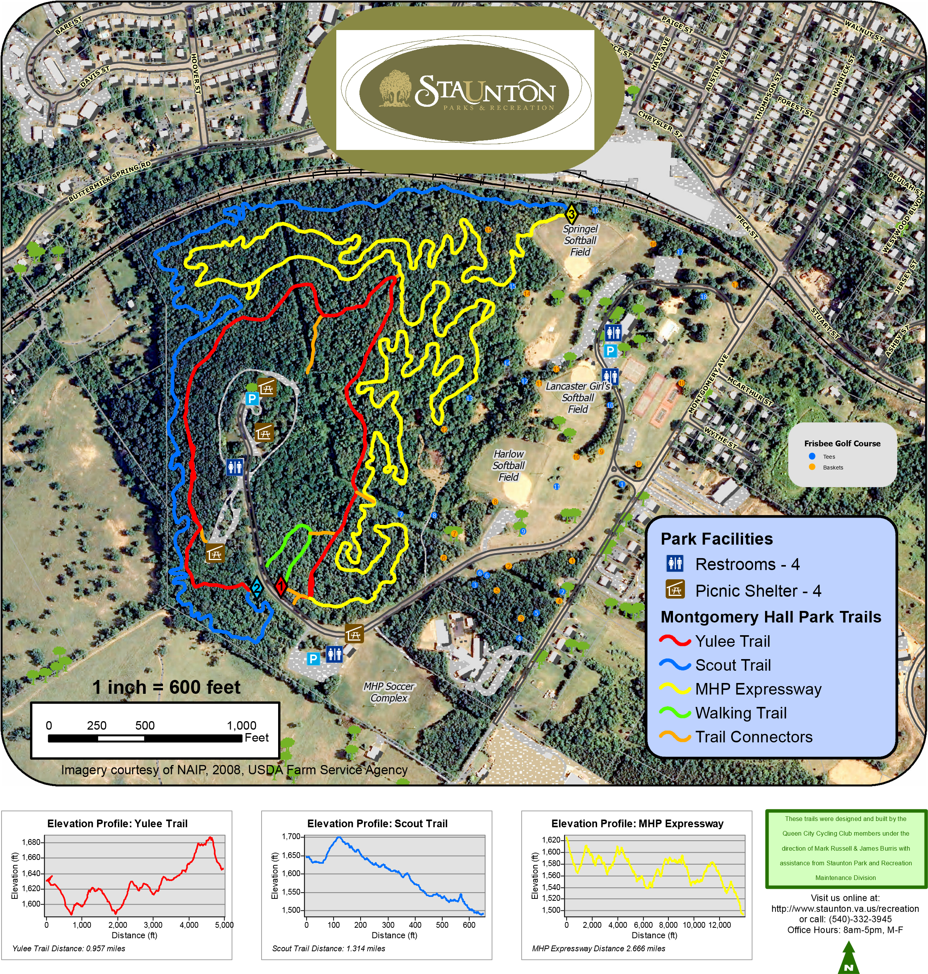
The above trail elevation profiles require a defined"Starting Point" and "Ending Point". There are, however, no formal Starting or Ending points.
For the purpose of properly interpreting the Profile Graphs please see below:
Trail Entrances
X
Y
1
X
Y
2
X
Y
3
- The "Starting Point" for the Yulee Trail is Trail Entrance 1 and the "Ending Point" for the Yulee Trail is Trail Entrance 2.
- The "Starting Point" for the Scout Trail is Trail Entrance 2 and the "Ending Point" for the Scout Trail is Trail Entrance 3
- The "Starting Point" for the MHP Expressway is Trail Entrance 1 and the "Ending Point" for the MHP Expressway is Trail Entrance 3
Helmets are recommended and REQUIRED BY LAW for all riders under 14 years of age

