PUBLIC NOTICE
OF
INTENT TO AWARD

DATE: |  | March 27, 2024
PROJECT: |  | Shelburne Middle School Renovations & Additions
IN RESPONSE TO: |  | RFP # 3636-1 Dated: March 12, 2024
VENDORS: |  | Nielsen Builders, Inc.
 | POSTED BY:
 | 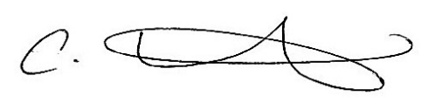
 | CHAD HORVAT
 | FINANCE BUSINESS MANAGER

