CITY OF STAUNTON

REQUEST FOR PROPOSALS (RFP)

RENTAL OF BUSINESS SPACE
NEAR NEW STREET PARKING GARAGE

April 2, 2021

GENERAL INFORMATION
The City of Staunton is seeking proposals from qualified individuals or businesses for the rental of business space near the New Street Parking Garage, 35B S New Street, downtown Staunton.
All proposals must be in an opaque, sealed envelope or box and clearly marked: “RENTAL OF BUSINESS SPACE - NEW STREET GARAGE”. Proposals shall clearly indicate the legal name, address and telephone number of the Offeror (company, firm, partnership, or individual). All expenses for making proposal to the City of Staunton shall be borne by the Offeror.
Offerors shall provide one (1) paper copy and one (1) identical electronic PDF copy (on CD or thumb drive) of the proposal documents. All electronic copies shall be exact PDF scanned copies of the original, signed, completed documentation.
Proposal documents shall be mailed to addressee below or hand-delivered to the City of Staunton Finance Office located at 116 W. Beverley Street, 3rd Floor City Hall, Staunton, Virginia. Office hours are Monday through Friday, 8:00am to 5:00pm. Faxed or emailed proposals will not be accepted.
All written proposals and must be delivered to:
Mail to: |  | Overnight To
City of Staunton |  | City of Staunton
Chad Horvat |  | Chad Horvat
Finance Business Manager |  | Finance Business Manager
P.O. Box 58 |  | 116 W. Beverley St., 3rd Floor
Staunton, VA 24402-0058 |  | Staunton, VA 24401
Phone: (540) 332-3819 |  | Phone: (540) 332-3819

ALL PROPOSALS MUST BE RECEIVED BY
2:00 P.M. LOCAL TIME, APRIL 26, 2021

The City of Staunton is not responsible for delays in the delivery of the mail by the U.S. Postal Service, private couriers, or the inter-office mail system. It is the sole responsibility of the Offeror to ensure that its proposal reaches the Supervisor of Purchasing by the designated date and hour. Facsimile and e-mail submittals are not acceptable.
All offerors shall abide by all applicable State and Federal laws. The City does not discriminate against small and minority businesses or faith-based organizations.

INQUIRIES CONCERNING RFP
Any questions or comments concerning this Request for Proposal shall be directed in writing to Jeff Johnston, Public Works Director, at johnstonjm@ci.staunton.va.us.

RFP SPECIFICATIONS FOR
CITY OF STAUNTON

RENTAL OF BUSINESS SPACE NEAR NEW STREET GARAGE

- INTRODUCTION
The City of Staunton is seeking proposals from quality businesses for the lease of approximately 432 square feet (approximately 16’4” x 28’ 4”) in the New Street Parking Garage at 35B South New Street in downtown Staunton, Virginia. The space was developed as a “storefront” in the South New Street façade of the parking garage structure, facing South New Street at the corner of New Street and Greenville Avenue. The Staunton Visitor Center operates in the adjacent space at 35A South New Street. The City desires to locate a quality business in this space that is compatible with the Staunton Visitor Center and complementary to the existing mix of downtown businesses including over 30 locally-owned restaurants and over 100 unique specialty shops and galleries.
- BUILDING SPECIFICATIONS
Building Space
The space is comprised of 432 square feet. (See attached Exhibit A.) The space has a front door entrance from South New Street and a back door entrance from inside the New Street Parking Garage. There are large front and rear windows for visibility onto the street and into the parking garage. This space is connected by an interior hallway to public restrooms and to the Staunton Visitors Center. For overnight security purposes, the space and the Staunton Visitor Center can both be locked separately.
Interior Finish
The space has tan-colored, split-face cinder block walls with maroon accents, a dropped ceiling with track lighting, and dark green, low-pile carpet. Two water fountains are also in the space. The potential tenant may make leasehold improvements as long as they are pre-approved, in writing, by the City of Staunton. In no case shall the tenant drill holes into the walls.

Restrooms
Accessible men’s and women’s restrooms are situated between the Staunton Visitor Center and the space and will be available to the space.
Parking
Short-term, on-street parking may be available in the block of South New Street in which the space is located. The New Street Parking Garage, the structure in which the space is located, has 277 parking spaces. There are some monthly parking passes in the garage, but a substantial number of the spaces are available for hourly customer parking. The parking garage also accommodates parking for patrons of the Hotel 24 South and the Blackfriars Playhouse on South Market Street and other area businesses and tourism attractions.
- UTILITIES
Electric
Only one electric service meter is in this area. Therefore, electric will be provided by the City and will be included in the negotiated lease price. Central electric heating and air conditioning is installed in the space.
Telecommunications
Basic wiring for telephone and internet is available. Local business exchange telephone service is available from Verizon and Ntelos. DSL and higher-speed internet service is also available. Activation of service and billings for telephone, internet, and other telecommunications services will be the responsibility of the tenant.
Water and Sewer
Water and sewer service will be provided by the City and included in the negotiated lease price.
- BUILDING SERVICES
Refuse and Recycling
The City collects refuse on Monday, Tuesday, Thursday and Friday. Recycling is collected on Mondays and Thursdays in the central business district. The tenant will be responsible for establishing refuse service at this location. Refuse is invoiced every other month.
Custodial
The tenant will be responsible for custodial care of the space. The City will provide custodial services for the adjacent restrooms.
- TERMS OF LEASE
Rental Rate
The annual rental rate per square foot will be negotiated with the tenant.
Length of Lease
The length of the lease will be negotiated. The City expects a minimum lease commitment of 12 months and a longer-term lease is preferred.
Miscellaneous Terms
The lease will include such other terms as are customarily required by the City of Staunton.
- GENERAL REQUIREMENS
Proposals should be as thorough and detailed as possible so that the City may properly evaluate the capabilities of respective firms that wish to lease the space. At the same time, proposals should be concise (a maximum of 10 pages) and supply information based on the following criteria:
- Firm History and Organization
- Business Contact(s): Identify and provide resumes (may be abbreviated), including references, for key business contacts.
- Experience: Provide a description of the operator’s background and/or business experience.
- Business Description: Please describe the retail or other business activity that will be carried out in the space. Also include:
  - Proposed hours of operation,
  - Plan to finance the business operation and building rent,
  - Proposed term of the lease, and
  - Identification and description of any improvements planned to the building space.
- Availability: The City would like to execute a lease agreement for the space as soon as possible. Please discuss your timeline and preferred “move-in” date.
- Insurance: The City carries insurance on this building. However, the successful applicant is responsible for all contents and agrees to carry commercial general liability insurance in an amount not less than $1,000,000 per occurrence with a $2,000,000 aggregate limit. Coverage shall be on an occurrence basis with the insurer licensed to conduct business in the Commonwealth of Virginia. The insurer must have an A.M. Best Rating of A- or better. The insurer must list the City of Staunton, Virginia as an additional insured. The endorsement must be issued by the insurance company.
- REVIEW AND AWARD
To be considered for selection, applicants must submit a complete response to this Request for Proposals. Failure to submit all information requested may result in the rejection of the incomplete proposal. City staff will review proposals. A maximum of the three most qualified firms will be invited for interviews by the City.
An authorized representative of the applicant shall sign the proposal. E-mail and facsimile responses are not acceptable.
The City will consider the following criteria in evaluating the responses to this RFP:
- Proposed Monthly Rent Amount: The preference for a competitive monthly rent will be a factor.
- Term of Lease: The preference for a longer-term lease will be a factor.
- Financial Standing: The applicant’s ability to finance the business is important.
- Demonstrated Business Background: The City seeks an applicant with a strong business background and a good business plan for the proposed business. A business plan (or parts thereof) for the proposed use may be attached as an exhibit and will not count toward the 10-page limit.
- Quality and Appearance: The City is seeking a business that is attractive and that presents a quality appearance. While not required, the City welcomes visuals to be incorporated into proposals as exhibits.
- Products and/or Services for Shoppers and Visitors: The City prefers to lease the space to a business which provides quality products and services for shoppers and visitors, especially goods and services that are not currently provided in the central business district.
- Compatibility with the Visitors Center and Extended Business Hours: The City is interested in proposals for businesses that complement the Staunton Visitor Center and are open to extending business hours after 5:00 p.m. and on weekends as part of the City’s efforts to promote additional customer traffic and shopping in the downtown area.
An Evaluation Committee will evaluate the proposals using the following minimum criteria:

RANKING CATEGORIES |  | SCORE WEIGHT
Proposed Monthly Lease Amount |  | 20
Length of Lease |  | 20
Financial Standing |  | 15
Demonstrated Business Background |  | 15
Quality and Appearance |  | 10
Products and/or Services for Shoppers and Visitors |  | 10
Compatibility with the Visitor's Center and Extended Business Hours |  | 10
FINAL SCORE |  | 100

ADDENDA TO RFP
Amendments to this RFP may be necessary prior to the closing date and will be posted to the Staunton City web-site. Prior to submitting their RFP, offerors are encouraged to visit the Staunton City web-site at http://www.staunton.va.us/solicitations for any addenda.

PROPOSED SCHEDULE
Activity | Date
Release RFP | April 2, 2021
Deadline for Submission of Questions | April 14, 2021
Deadline for Submission of Proposals | April 26, 2021, 2:00 P.M.
Evaluation of Proposals and Selection Process | May 3-7, 2021

EXHIBIT A

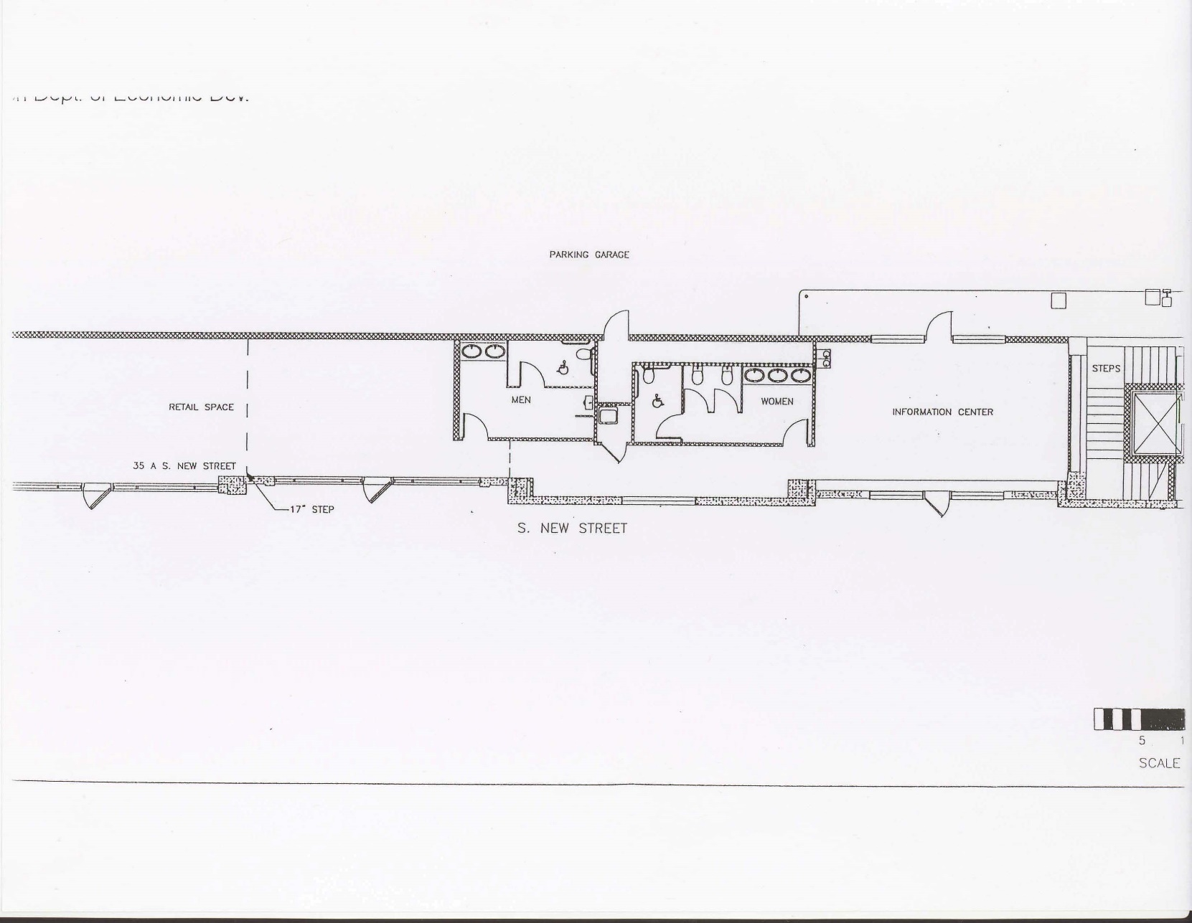

NEW STREET PROPERTY
LEASE APPLICATION

Applicant Name:
Applicant Address:
Applicant Phone Number:
Business Name:
Business Description (attach business plan if available):
Proposed Hours of Operation:
Proposed Length of Lease:
Proposed Monthly Lease Amount:
Planned Space Improvement:
Business History/Experience:
Business Contact(s)/References:
Anticipated Move-In Date:
Include this form with RFP submission.

